CSE 455 Homework 6
Content Based Image Retrieval
Name: Zhuonan Sun

- Introduction
Develop a content-based image retrieval system that retrieves database images based on the similarity between their regions and those of query image.

- Description of your system
Describe in detail how you have implemented color segmentation, connected components finding, region attributes computation ( must include size, mean color, energy, entropy and contrast based co-occurrence texture features, centroid, bounding box or other representation of where the region is, and region adjacency graph for two person teams), how you store the attributes and relationships in a data structure, with distance measures you experimented with, and which one performed best and used in your final results and how you perform query.

I did this homework by myself. First, I used kmean I wrote in hw4 to create a labeled image. However, the labeled image has too many small areas where connect regions program will not be effective. Then I tried to processe the image using opening (erosion followed by dilation) to eliminate small areas and merge all the regions whose sizes are below a threshold, where I used a program I created. However, using them gave me strange result, and I could not figure out the cause of the result. So I decide to skip those steps and move on. I used conrgn from hw1 to obtain a labeled segmentation image.

To reduce the negative effect from skipping the noise cleaning effect. I used a relatively large size threshold (5000) to filter the small areas when computing attributes of images. This way definitely helps to get a better result, according to 5 or 6 out of 8 groups of results.

For each major region, I computed 13 attributes of it: size, mean color in RGB, energy, entropy, contrast, centroid (row, column), upper-left corner (row, column) and lower-right corner (row, column) of its bounding box. Everything except three texture features is rather easy to compute. Size can simply be acquired by accumulation; mean color, centroid can be acquired after accumulation and a division at the end. Bounding box can be obtained by comparisons. Texture features must be obtained by acquiring co-occurrence matrix of the region first, followed by certain formulas. Given a spatial relation d(1, 1), update the region’s co-occurrence matrix. The matrix can be filled after one iteration of the labeled image. With a complete matrix, texture features can be computed after one Iteration of the matrix. But before using the result in calculation, normalize it, so that the formulas will work. Using formulas below would give us the right texture features results.

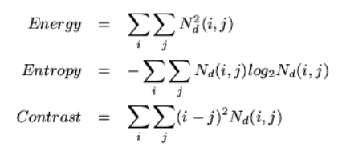

All the attributes of regions will be stored in a 2D array, with a height of amount of regions, and a width of 13. At the end, print the 2D array to a text file for future use.

Next step is to write a program that can calculate the distance RELDIST (I1, I2) between DS (I1) and DS (I2) for any two images I1 and I2. To find the distance, a correspondence between regions of I1 and regions of I2 need to be found. But first, the 2D attributes array need to be retrieved for each image, which can be done by reading the text files created from the last step. Then, check every region of image 1, finding its closest match in I2 by checking every region in image 2. The best match is the match with the shortest distance. There are two methods to calculate distance. With method 1, it can be calculated by summing up all squares of difference of each attribute between I1 and I2, and taking the sqrt of the sum. Method 2 is similar, but each attribute has certain weight, because not every attribute has the same impact on the distance, which proves its correctness since method 2 had a better result in the test. As the best match is found, add the distance between the two regions to RELDIST, initially zero. The region been matched will be inserted in a set, which will remind the program not to use it again for matching. After traversing all regions in image1, correspondence is found with RELDIST mostly calculated. However, RELDIST still needs to be modified because all the unmatched regions need to take penalty. Therefore, add amount of unmatched regions * WEIGHT w, to RELDIST. Finally, print the attributes text name (not the query image one) and RELDIST to a text file for the query.

The last step to create a query system. Run the shell code to compare query image Q to each image I in the database and fill RELDIST in the text file created from the last step. I created a program to read this file, and sort the images’ names by comparing their corresponding distances. The sorted result (image names and distances) will be printed to a result text file

Method 1 gave me huge number of distance because size plays the same role as every other attribute, and (difference between sizes)^2 is huge sometimes. Some other attributes have the same problems, such bounding box and mean color. Adding weights to attributes solve the problem.
All the results shown below are from Method 2

To use the program:
- ./get_attributes.sh
- ./computeDist.sh
- ./query.sh
Notes: clear xxx_x.txt, sorted_xxx_x.txt files before using the program.
chmod u+x program.sh if permission is denied
sed –i –e ‘s/\r$//’ query.sh if bad interpreter: No such file or directory warning is received

- Testing results
The database should consist of the 40 provided images. The following images should be used as queries:
beach_2
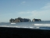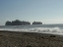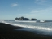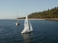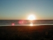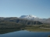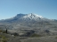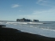

0 863 954 976 979 1045 1128 1129

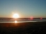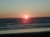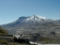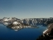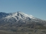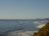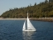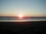

1133 1154 1168 1191 1210 1227 1234 1236

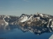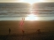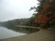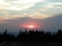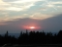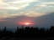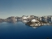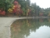

1337 1380 1395 1449 1465 1477 1520 1578

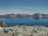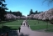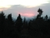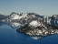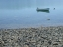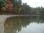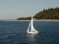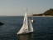

1591 1625 1630 1634 1669 1712 1000960 1001270

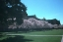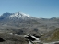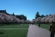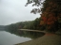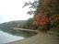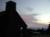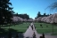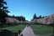

1001290 1001470 2001230 2001350 2001410 2001730 3001190 3001250

boat_5
0 696 801 937 989 1058 1085 1086 1091

1125 1138 1141 1143 1158 1166 1177 1196 1197

1222 1225 1242 1243 1254 1255 1265 1271 1278

1287 1306 1461 1485 1516 1522 1523 1001220 1001230

1001290 1001640 2000920 2001030

cherry_3
0 484 510 726 930 942 975 979 1034

1042 1046 1052 1064 1066 1069 1090 1091 1092

1105 1112 1120 1130 1134 1170 1174 1183 1190
1201 1219 1229 1238 1251 1253 1340 1372 1385

1411 1438 1470 1475

crater_3
0 937 988 1016 1099 1119 1130 1148 1191

1191 1252 1288 1304 1320 1334 1362 1398 1429

1450 1470 1499 1500 1518 1528 1568 1623 1628

1686 1706 1710 1001300 1001390 1001420 1001440 2001190 2001320

2001470 2001560 3001120 3001250

pond_2
0 599 896 1091 1102 1103 1122 1123 1129

1222 1236 1240 1259 1284 1292 1301 1322 1327

1335 1343 1345 1369 1396 1407 1413 1424 1440

1449 1454 1485 1489 1496 1500 1581 1615 1648

1656 1753 1001280 1001430

stHelens_2
0 1113 1134 1779 1794 1809 1815 1895 1981

1001070 1001690 1001850 1001900 1001960 1002180 1002220 2001400 2001500

2001710 2001710 2001880 3001320 3001460 3001470 3001500 3001590 3001710

3001810 3001820 3001930 4001510 4001530 4001560 4001770 5001660 5001810

5001890 5002110 6001520 6001800

sunset1_2
0 1216 1265 1360 1490 1621 1773 1991 1999

1001480 1001530 1001590 1001600 1002020 1002090 1002210 2001610 2001620

2001690 2001920 2002030 3001290 3001480 3001500 3001590 3001650 3001720

3001780 3001920 3002020 4001690 4001780 4001950 4002150 5001890 5001910

5002040 5002150 6001600 6001780

sunset2_2
0 1085 1197 1199 1333 1356 1432 1479 1553

1743 1771 1873 1905 1912 1958 2324 1001350 1001370

1001470 1001770 1002080 2001100 2001280 2001350 2001370 2001490 2001630

2001690 2001700 2002130 3001290 3001490 3001670 3001700 4001380 4001730

4001740 4001800 5001220 5001240

- Extra Credits
Create a simple GUI for performing these queries and/or experiment with other features.

